**Word normalization,trigram example**

**NLP:**

**(Emoji face detection)**

Branch of ai that helps computer what we say or write. That is machine is guessing or classifying.

Study of linguistics(meaning or grammar of sentence), comp science…….eg: google translate, alexa.

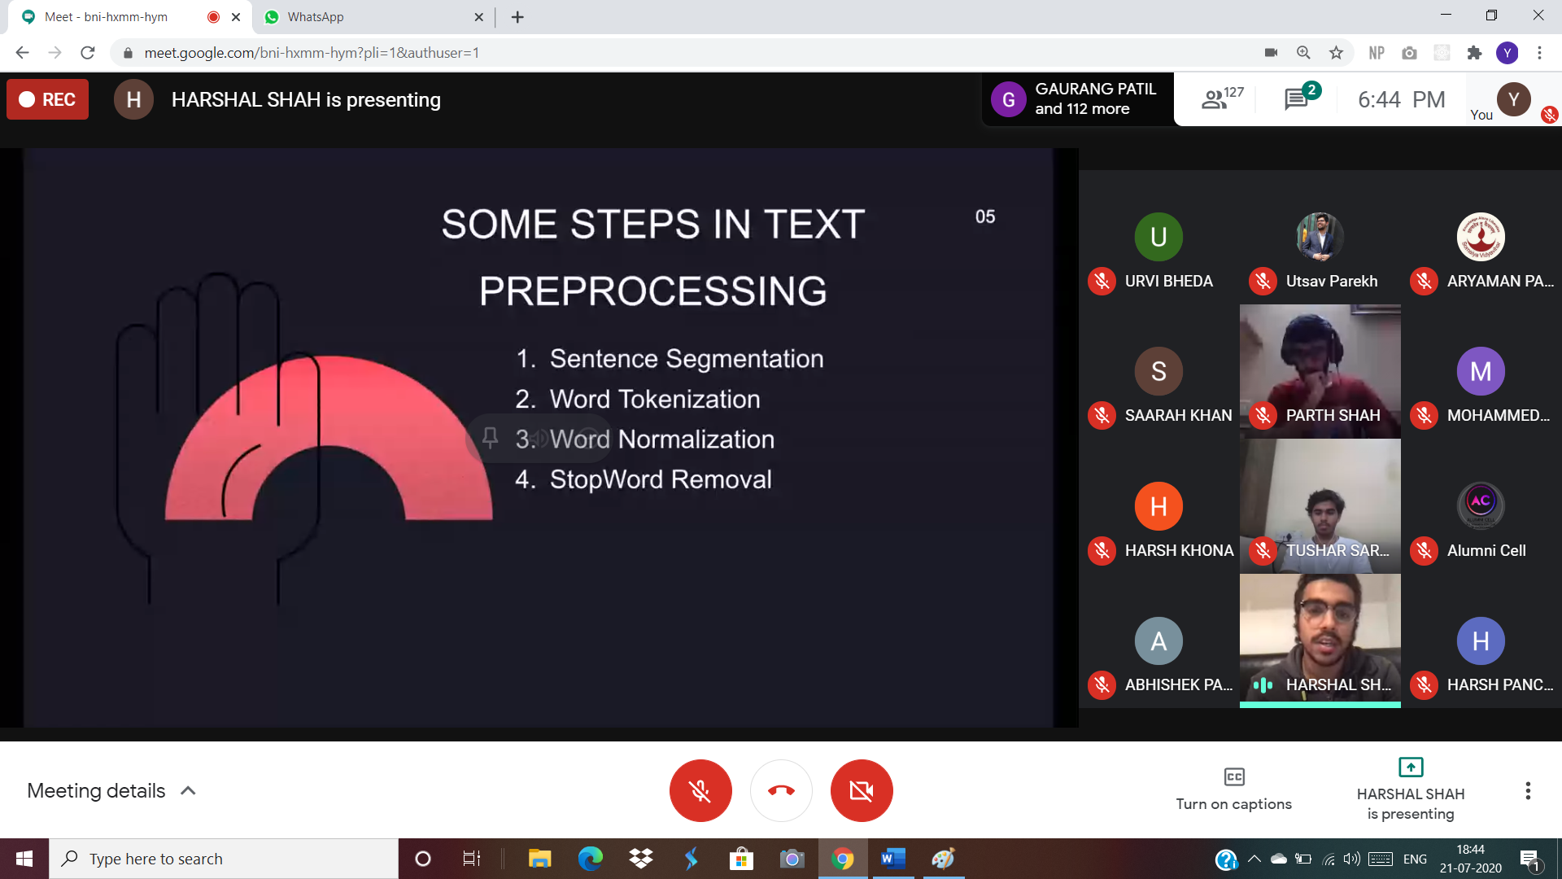

**N grams:**

Uni-,bi-,tri- grams

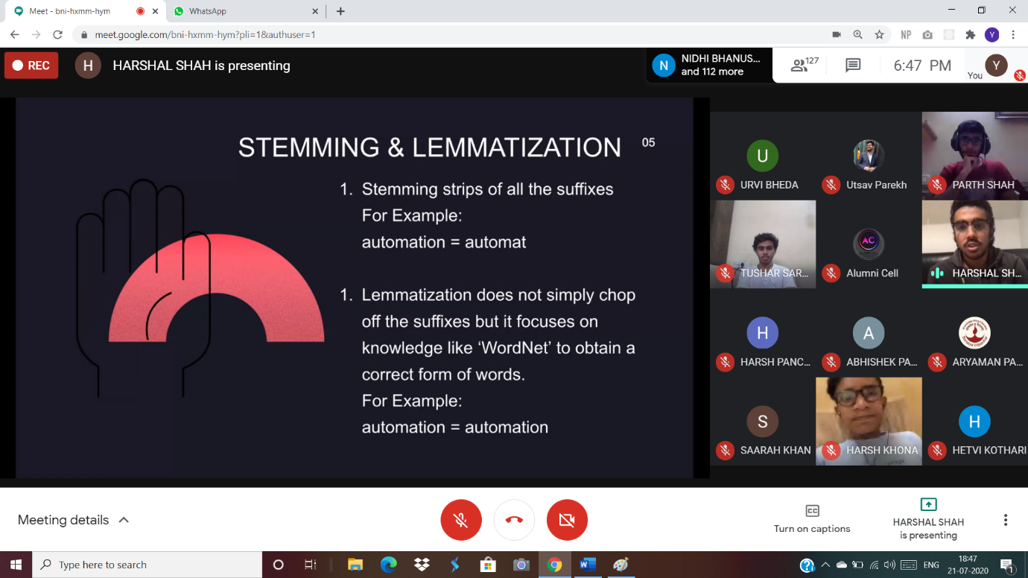

**Text vectorization**: converting sentence into vector of numbers that can be understandable by machine

Types:

Bag of words,

Tf-idf

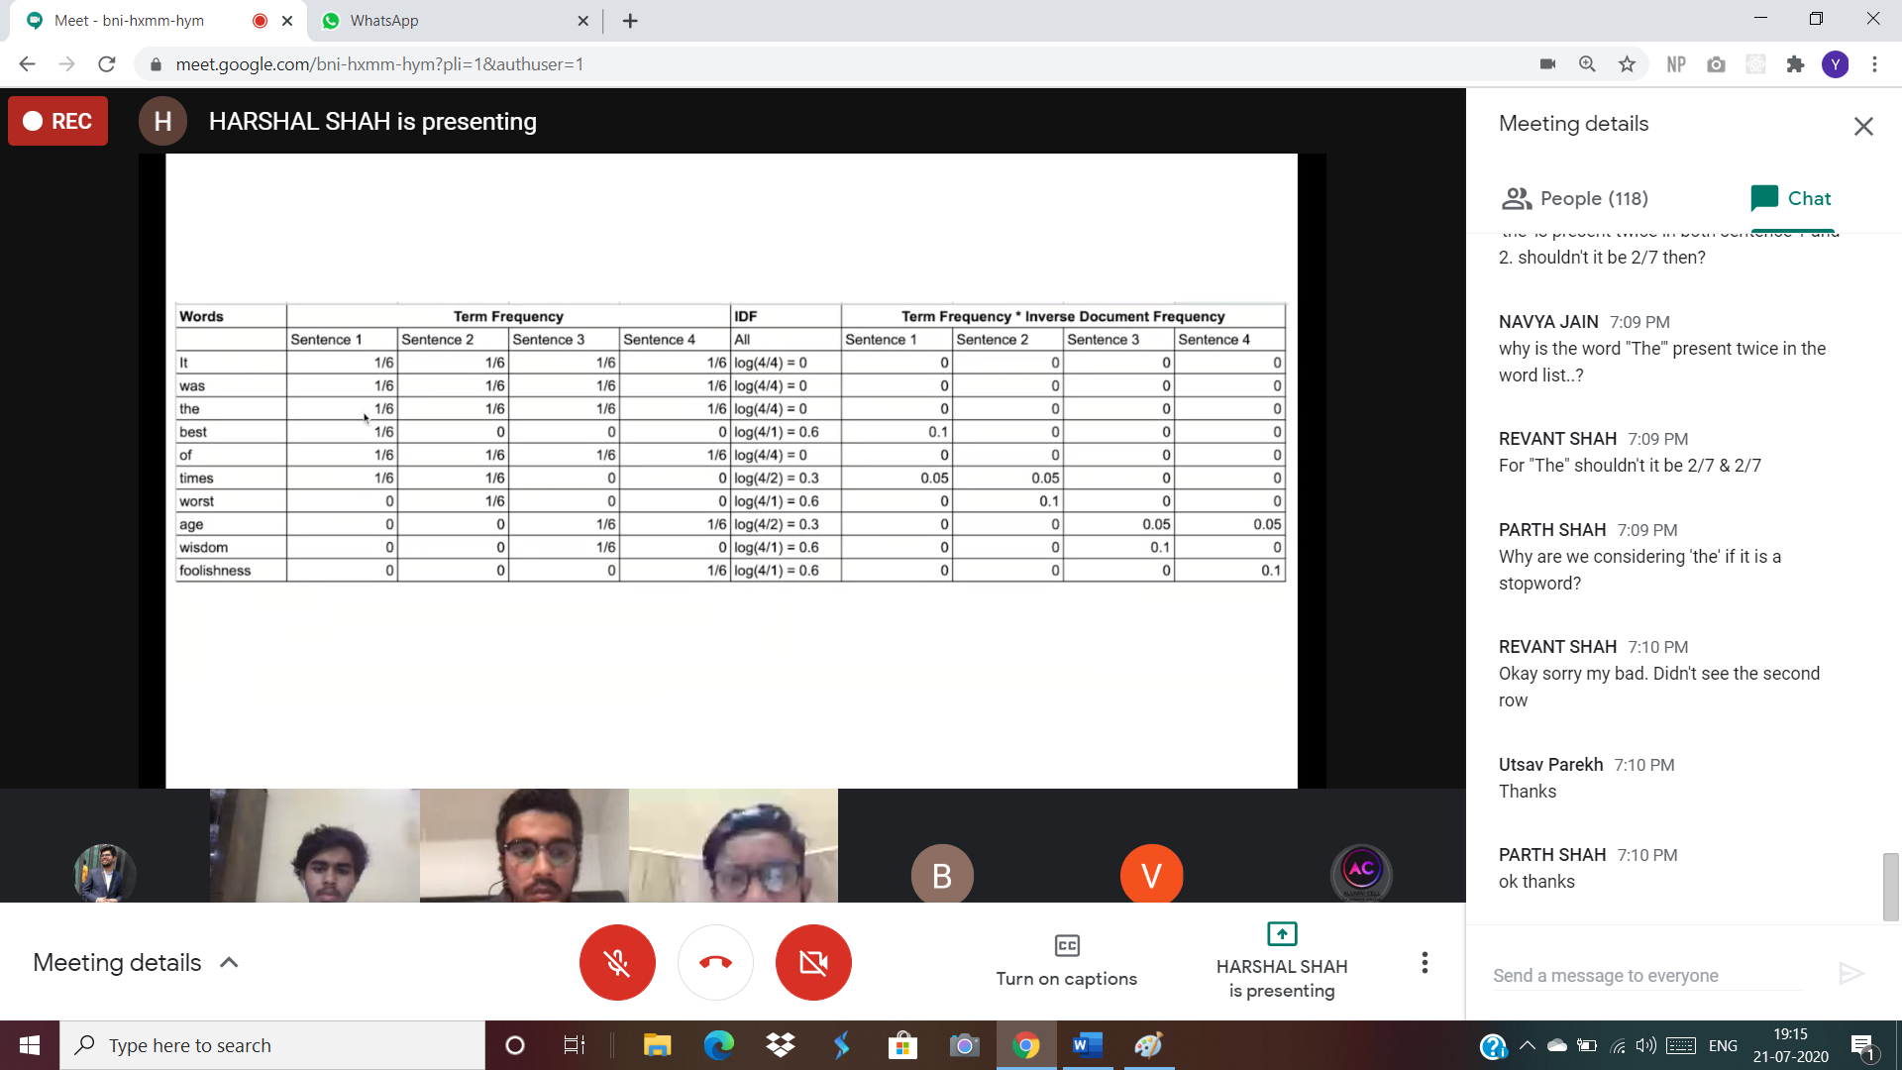

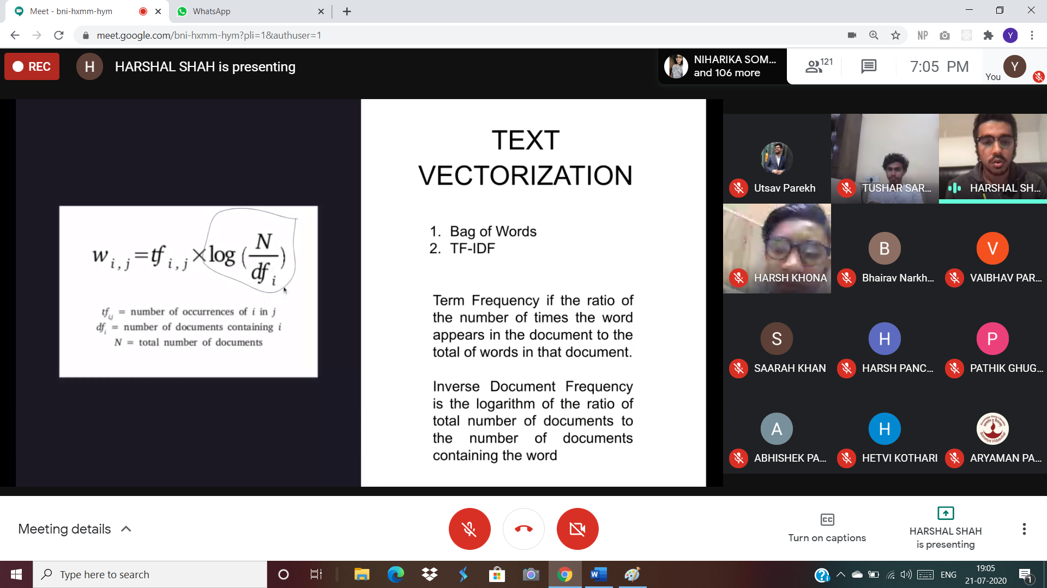

STOPPERS AND STEMMERS IN PYTHON:  
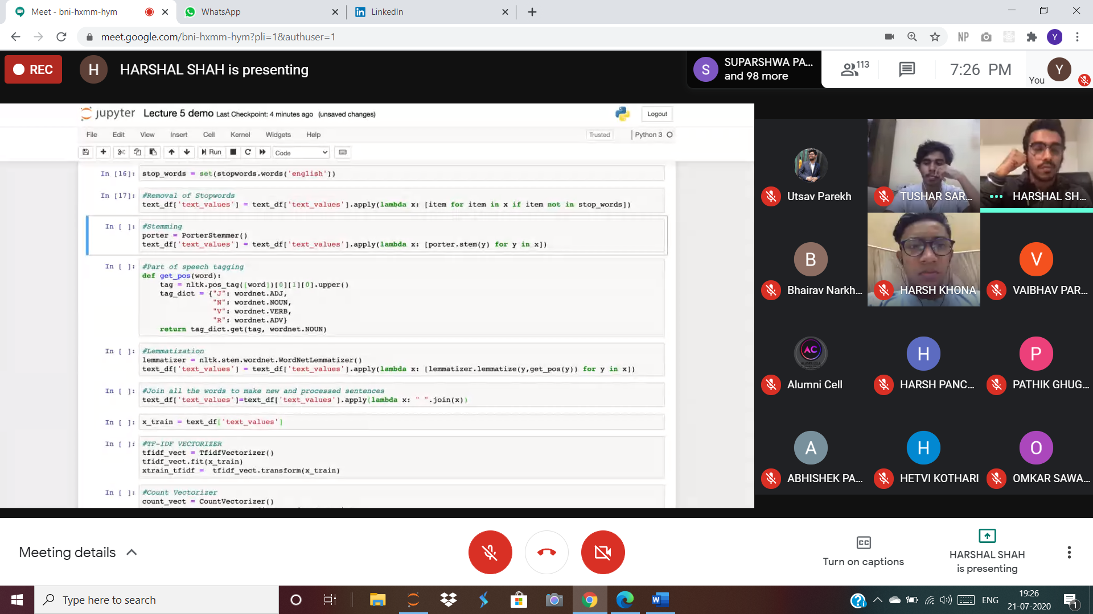

LIBRARIES:

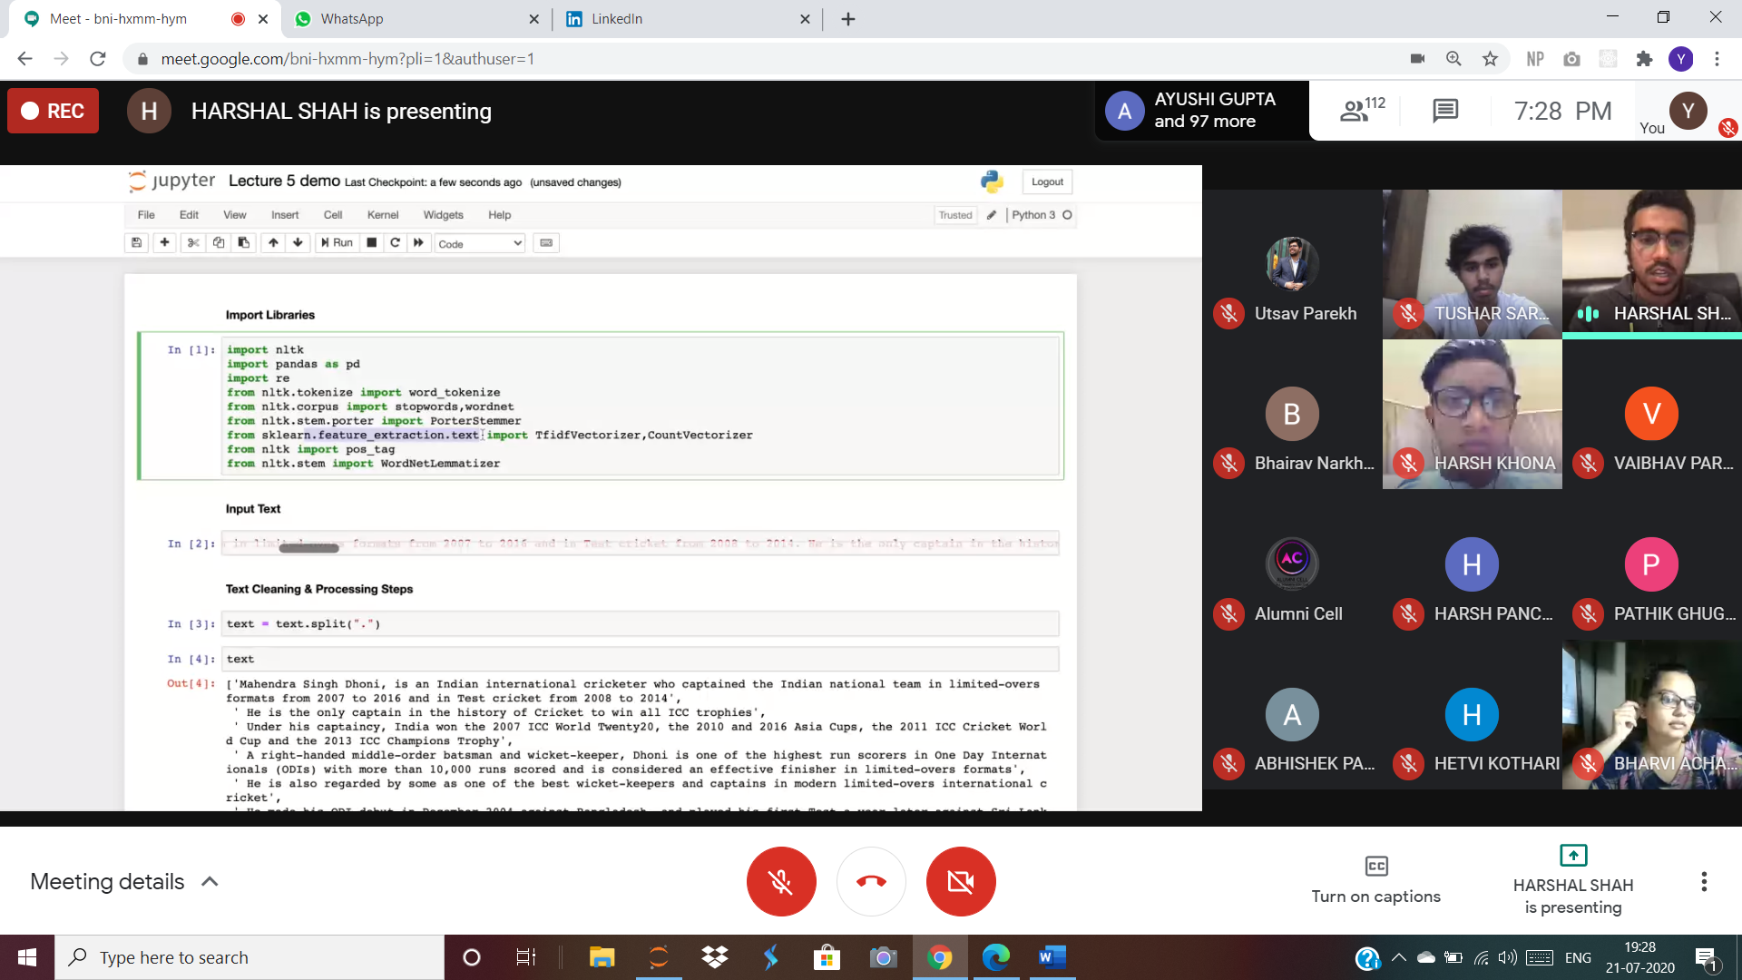

TFIDF IN PYTHON:

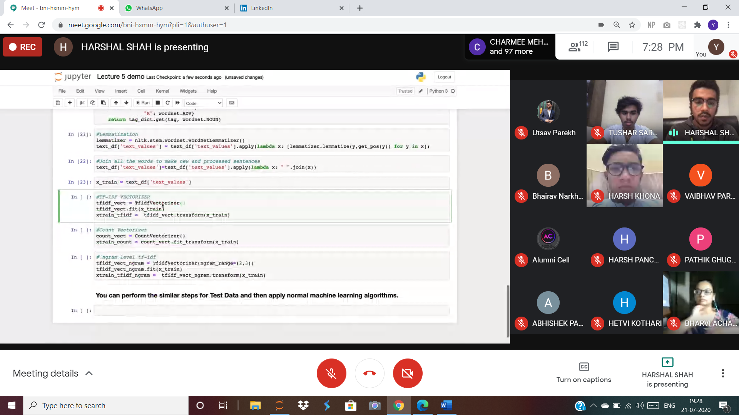

COUNT VECTORIZER:

